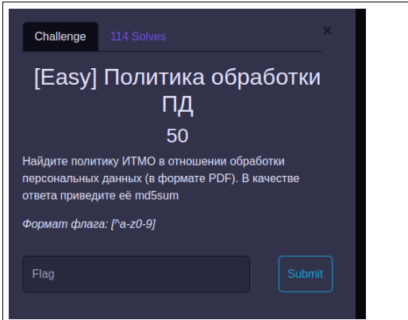
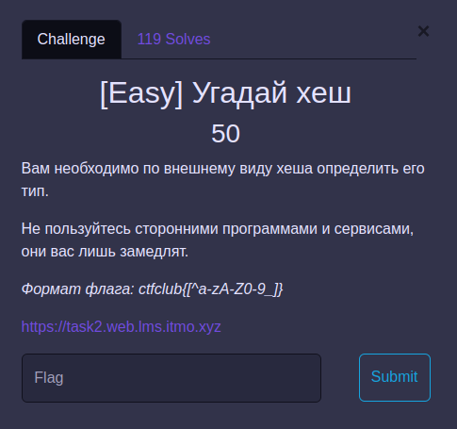
ctfclub{5P3edH@}
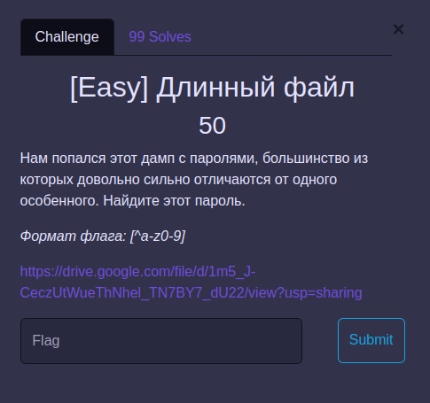
0c490bbac7c2601ed7bbd8bdb3bcd61cb3128d39b3a5553eec829af91d29cfe2b29f364958aa982aaf5daa1392785fd2
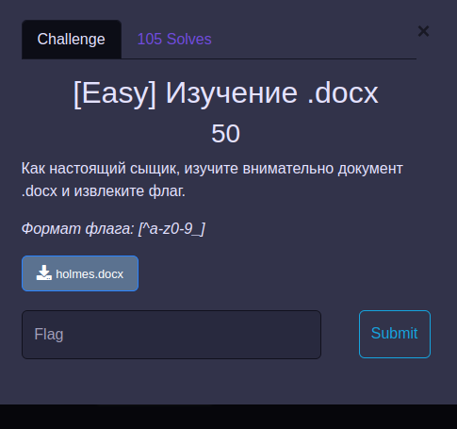
fabd8a56afc168067fd698b912be6ae89db43a1494decea313a9af084a85427e1fc1a864be71bfef136fea492a542e7d
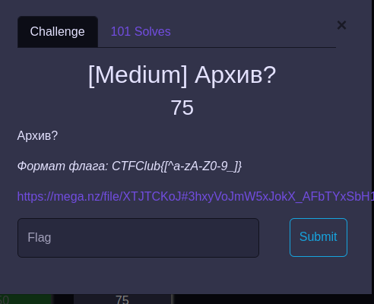

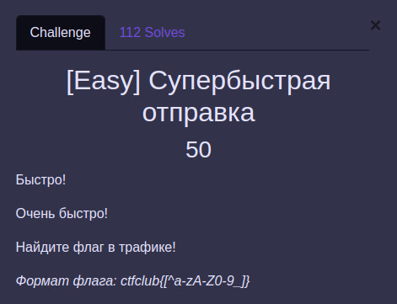
ctfclub{d15400bdb9a30cbd686961d4b20de6ff}
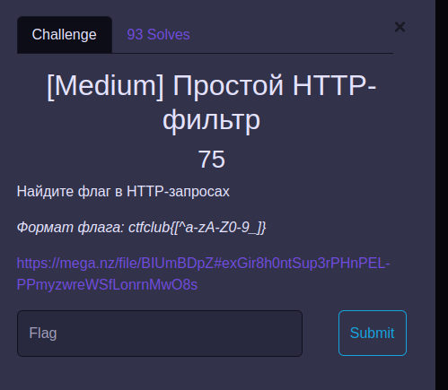
ctfclub{566863e59f5082b404a1184ac7e59290}
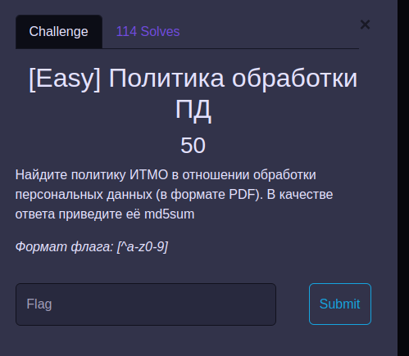
87e5d25b5afdac4bb209b7be38ba5967
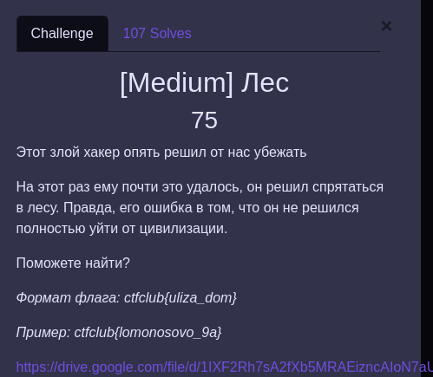
ctfclub{ozernaya_1a}
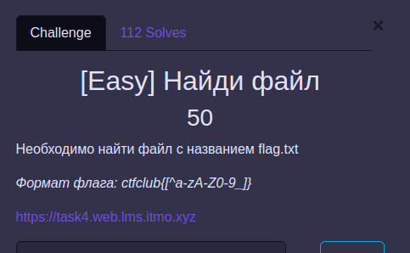
ctfclub{YOuhaVeF0UndTH3fiL3C0N6ra7$}
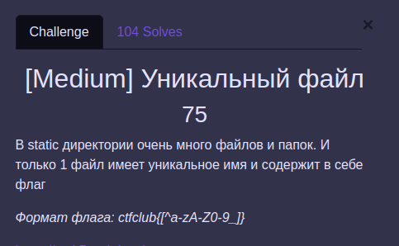
ctfclub{THiS0N3i5V3RYUn!9uEf!Le}
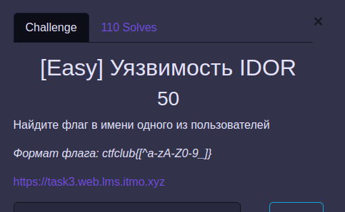
ctfclub{7OoManYVuLnER481LIT!3s}
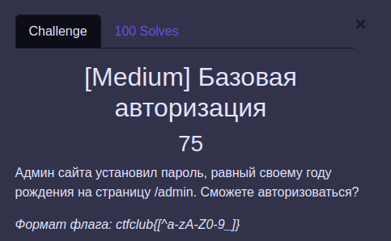
ctfclub{happybirthdaydearadmin}
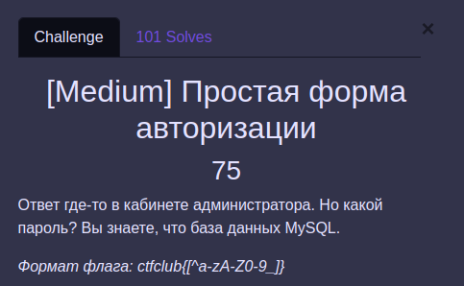
ctfclub{THiS0N3i5V3RYUn!9uEf!Le}
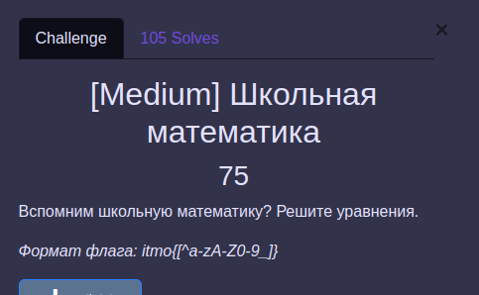
itmo{1234567890}
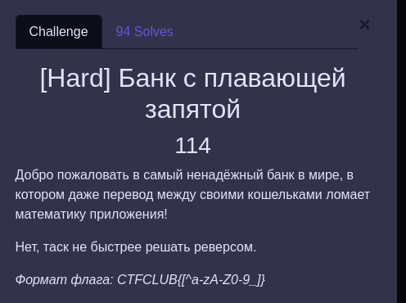
CTFCLUB{fL0at_1s_daNg3roUs}
CTFCLUB{th3_wRoNg_oRGan1zEr5_4Re_d0inG_tH3_WROng_t4sKS}

